Final Project

Problem Statement: A retail company Abstergo Corp. has recently setup an online shopping portal(website) to sell their products. Due to fierce competition, the company wants a solution that can reduce the time and effort it needs to enhance the functionality of their website on a regular basis. They are looking for an automated way to deploy the new code (for new features) to production website whenever they want.

Business Requirements

• The team of developers working on new features will merge their code to a GitHub repo.

• As soon as the code reaches GitHub, using a CI (Continuous Integration) pipeline, setup in Jenkins, automated builds will be triggered.

• The automated builds will frequently deploy new features to the production website.

• Every build will prepare a Dockerfile and push docker images to docker-hub.

• Every docker image will be deployed (Continuous Deployment) to a kubernetes-cluster.

Prerequisites:-

For this project below are the prerequisites:

1.

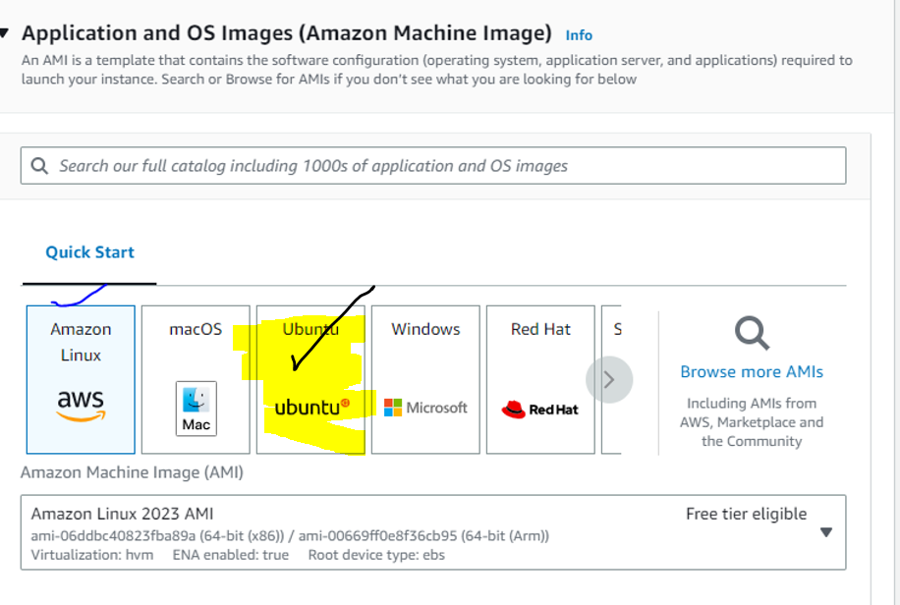

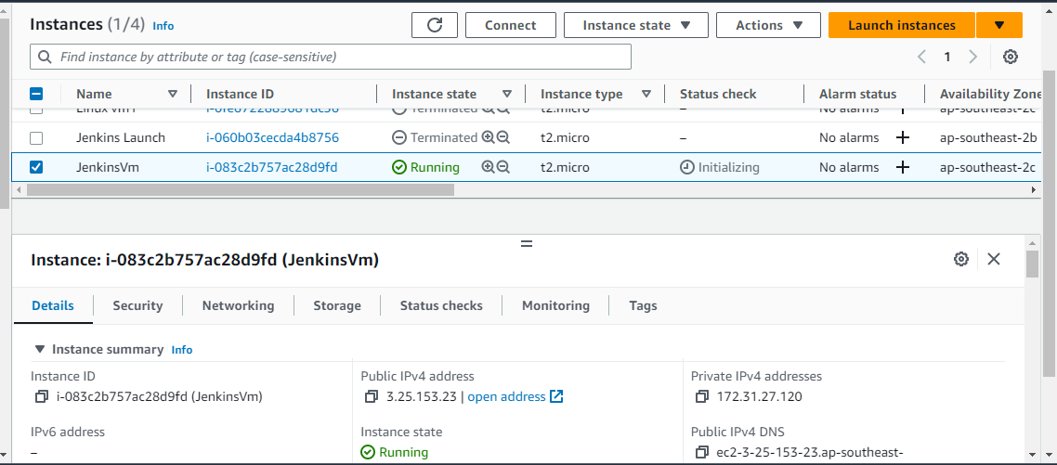

Launched Linux

Used su for super user right

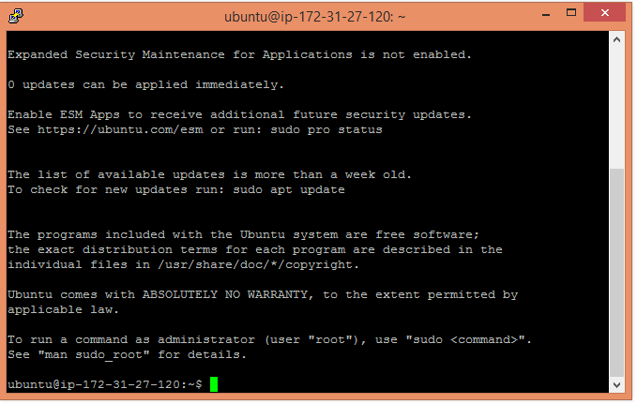

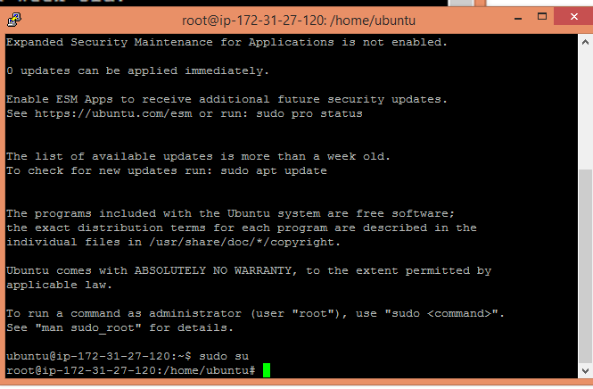

**sudo apt-get update**

**sudo apt install default-jdk**

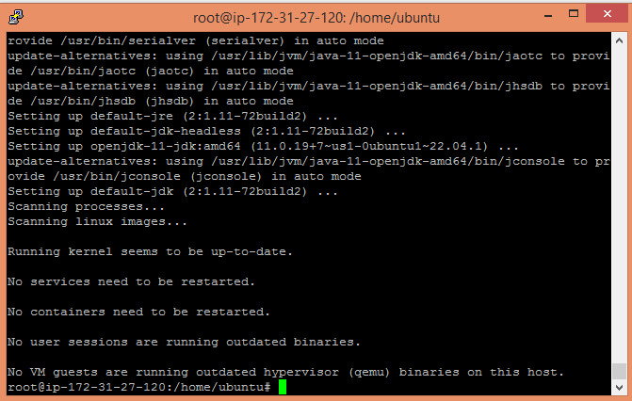

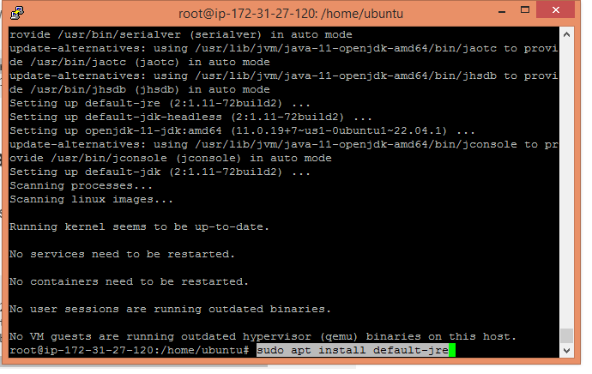

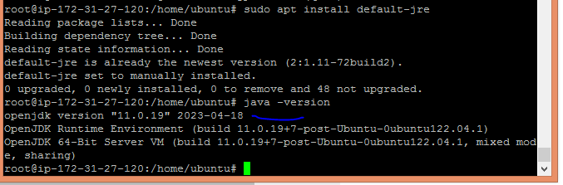

sudo apt install maven

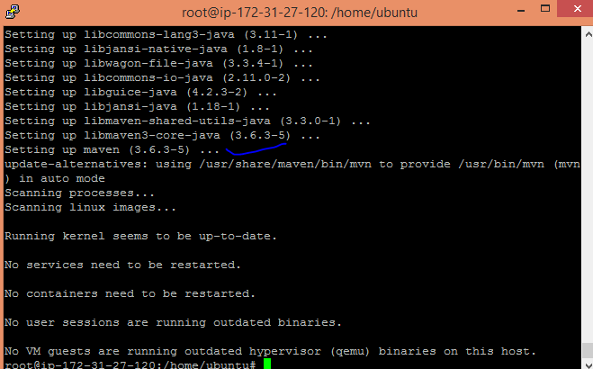

mvn –version

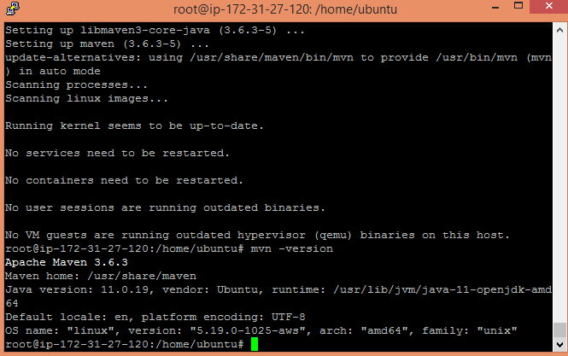

Installing Jenkins :

curl -fsSL https://pkg.jenkins.io/debian-stable/jenkins.io-2023.key | sudo tee\

/usr/share/keyrings/jenkins-keyring.asc **>** /dev/null

echo deb **[**signed-by**=**/usr/share/keyrings/jenkins-keyring.asc] \

https://pkg.jenkins.io/debian-stable binary/ | sudo tee\

/etc/apt/sources.list.d/jenkins.list **>** /dev/null

sudo apt-get update#Install Jenkins

sudo apt-getinstalljenkins-y

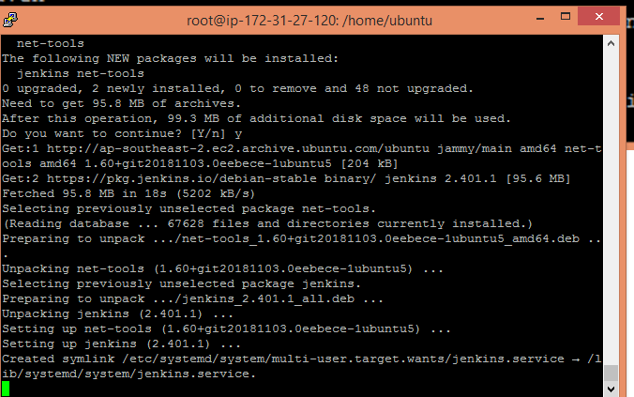

service jenkins start

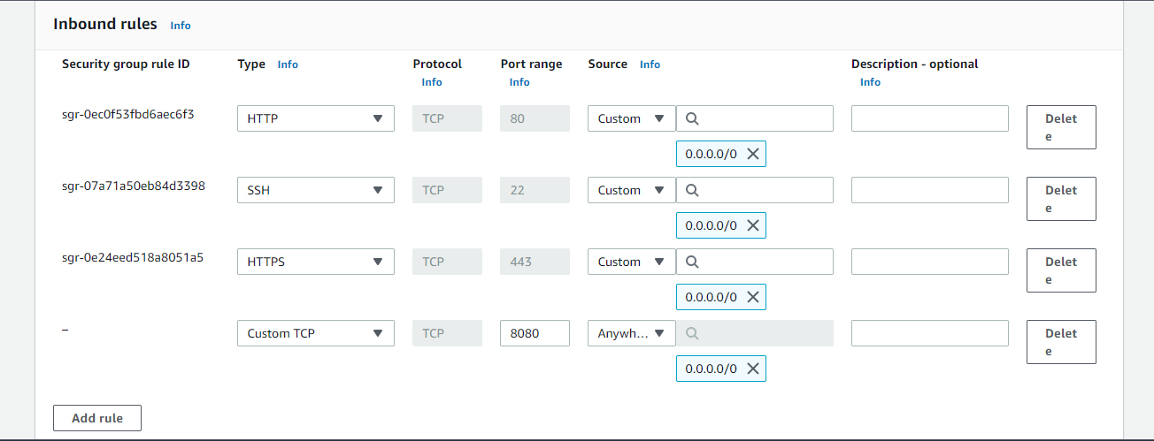

Now copy publicipandpasteit inthebrowser

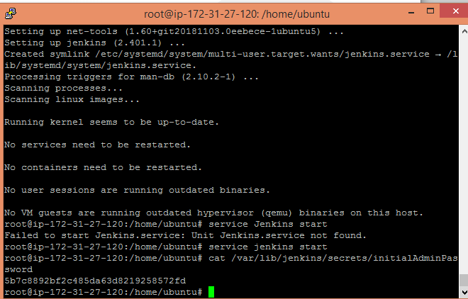

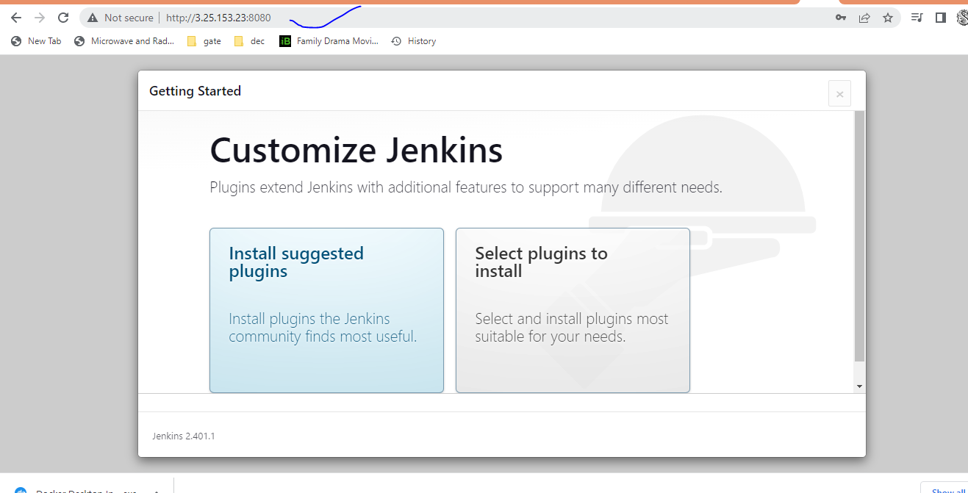

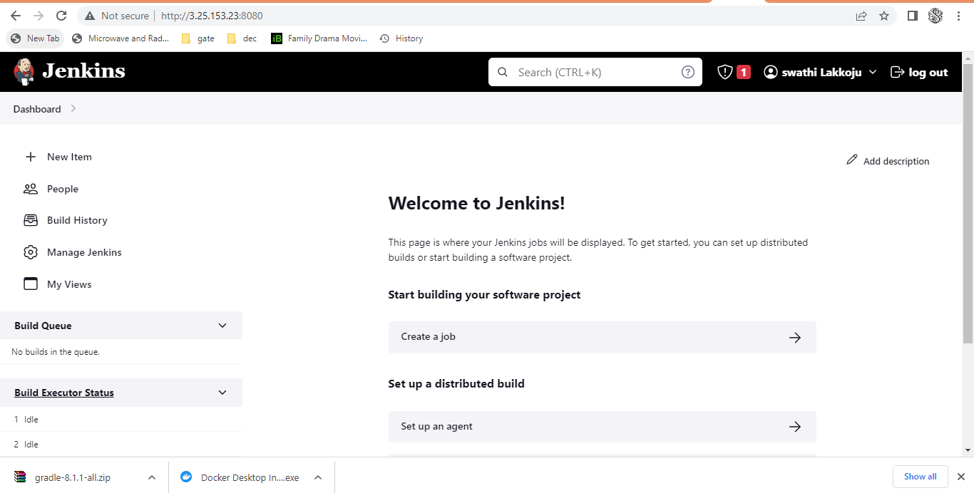

Now Installing Git

sudo apt install git

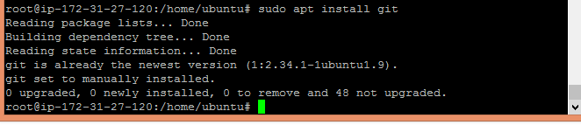

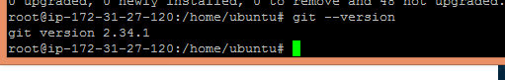

git config --global user.name "your_name"

git config --global user.email "email@address.com

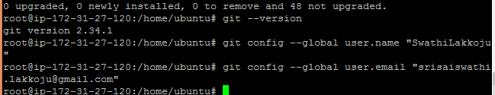

Installing Docker:

1. pdate and install dependencies
2. sudo apt-get update
3. sudo apt-get install ca-certificates curl gnupg lsb-release
4. Set up the Docker repository
5. sudo mkdir -p /etc/apt/keyrings
6. curl -fsSL https://download.docker.com/linux/ubuntu/gpg | sudo gpg --dearmor -o /etc/apt/keyrings/docker.gpg
7. echo "deb [arch=$(dpkg --print-architecture) signed-by=/etc/apt/keyrings/docker.gpg] https://download.docker.com/linux/ubuntu $(lsb_release -cs) stable" | sudo tee /etc/apt/sources.list.d/docker.list > /dev/null
8. Install the docker engine
9. sudo apt update

sudo apt-get install docker-ce docker-ce-cli containerd.io docker-compose-plugin

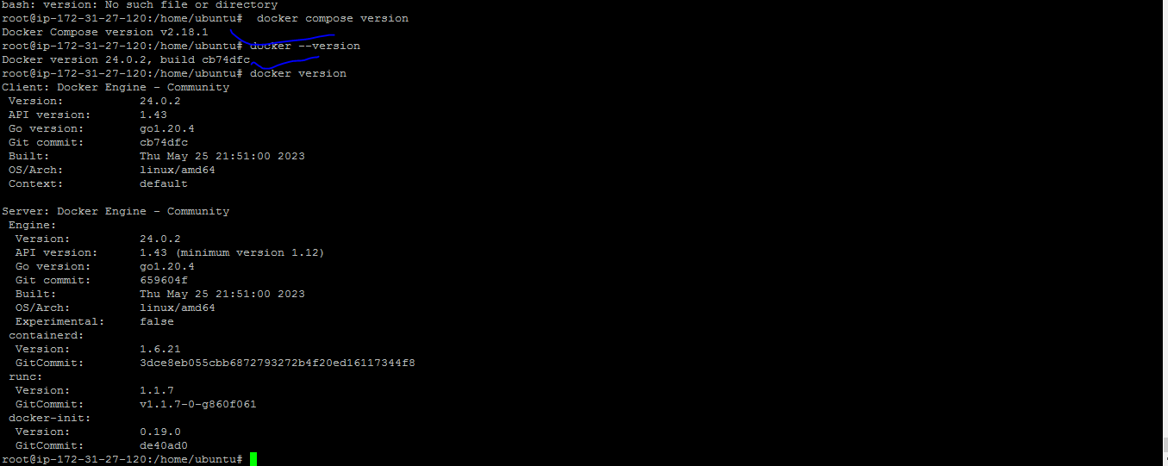

**###install Kubectl###**

curl -LO https://storage.googleapis.com/kubernetes-release/release/$(curl -s https://storage.googleapis.com/kubernetes-release/release/stable.txt)/bin/linux/amd64/kubectl && chmod +x ./kubectl && sudo mv ./kubectl /usr/local/bin/kubectl

**###install Minikube####**

curl -Lo minikube https://storage.googleapis.com/minikube/releases/latest/minikube-linux-amd64 && chmod +x minikube && sudo mv minikube /usr/local/bin/

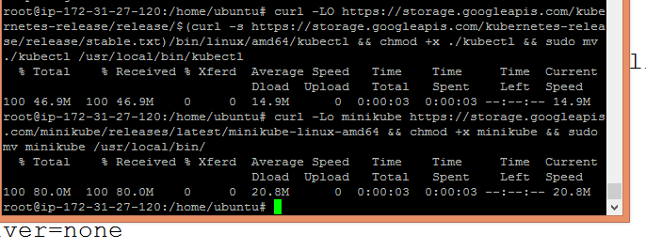

Till now I have installed git,Jenkins , Docker ,Minikube and Kubernetes in the ubuntu AMI . Now we are all set with required softwares for deploying application.

I have forked the given repository to my github account to use it as the application for your pipeline project GitHub: <https://github.com/bhavukm/cicd-pipeline-train-schedule-autodeploy>

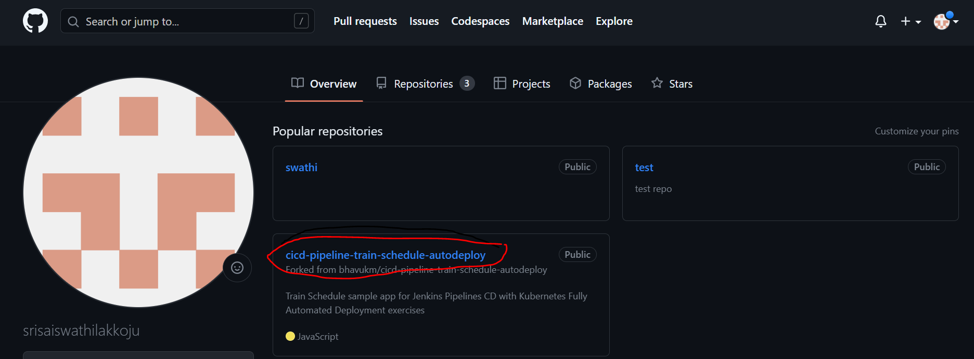

I have launched my Jenkins dashboard.

Now I will use Jenkins dashboard to interact with CI/CD pipeline that I create in next stages.

As we will use Docker we have to install plugin called Docker Pipeline Plugin .

Steps to install Plugin:-